**5.1 Using Fundamental Trig Identities**

**Objective: Use fundamental trig identities to evaluate, simplify, and rewrite trig expressions**

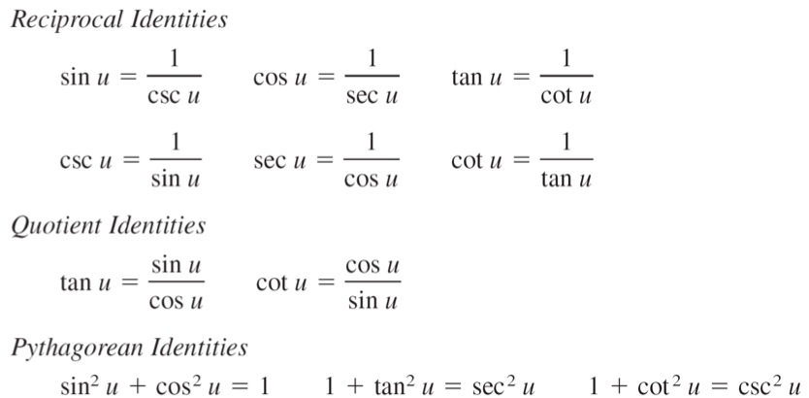

*Cofunction Identities*

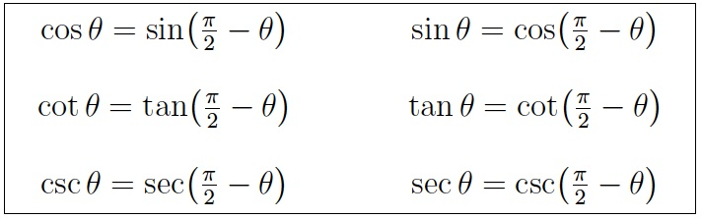

$$Odd-Even Identities$$

$$\sin\left(-u\right)=-\sin{u \csc\left(-u\right)=-\csc{u}}$$

$$\cos\left(-u\right)=\cos{u} \sec\left(-u\right)=\sec{u}$$

$$\tan\left(-u\right)=-\tan{u \cot\left(-u\right)=\cot{u}}$$

**Example 1**

Use the values of $\sec{u=-\frac{3}{2}}$ and $\tan{u>0}$ to find the values of all six trigonometric functions.

$cos u=\frac{1}{\sec{u}}{=\frac{1}{-3/2}=-\frac{2}{3}}$ $\sec{u=-\frac{3}{2}}$

*Note: since secant is < 0 and tangent is > 0 we know the value is in Quadrant III. Therefore sine is also negative.*

$sin^{2}{u=1-cos^{2}u=1-}$ ($-\frac{2}{3})^{2}$

$sin^{2}{u=1-}\frac{4}{9}=\frac{5}{9}$

$\sin{u=-\frac{\sqrt{5}}{3}} csc u=\frac{1}{\sqrt{5}/3}=-\frac{3\sqrt{5}}{3}$

$$\tan{u= \frac{\sin{u}}{\cos{u}}=\frac{-\frac{\sqrt{5}}{3}}{-\frac{2}{3}}}=\frac{\sqrt{5}}{2} cot u=\frac{1}{\sqrt{5}/2}=\frac{2\sqrt{5}}{5}$$

------------------------------------------

$cos u=-\frac{2}{3}$ $\sec{u=-\frac{3}{2}}$

$\sin{u=-\frac{\sqrt{5}}{3}} csc u=-\frac{3\sqrt{5}}{3}$

$$\tan{u}=\frac{\sqrt{5}}{2} \cot{u}=\frac{2\sqrt{5}}{5}$$

------------------------------------------

**Example 2**

Simplify:

🡨 Factor out sin x

🡨 Factor out -1 (combine with 1st step)

🡨 Pythagorean Identity

🡨 Simplify

**Example 3**

Factor:

🡨 Difference of Squares

**Example 4**

Factor:

🡨 Factor ${1x}^{2}+bx+c$

**Example 5**

Simplify:

🡨 Quotient Property

🡨 Common Denom. & Add

🡨 Pythagorean Identity

🡨 Reciprocal Identity

**Example 6**

Perform the addition and simplify:

🡨 Common Denominator

🡨 Distribute and Combine

🡨 Pythagorean Identity

🡨 Divide by Common Factor

🡨 Reciprocal Identity

**Example 7**

Rewrite so that the following is *not* a fraction:

🡨 Multiply (Difference of Squares)

🡨 Pythagorean Identity

🡨 Write as separate fractions

🡨 Product of fractions

🡨 Reciprocal & quotient identities

**Homework**

Day 1: Pg 377 #1-10, 13-14, 25-35 (odd)

Day 2: Pg 377 #16, 37-49 (odd), 75, 81, 123